
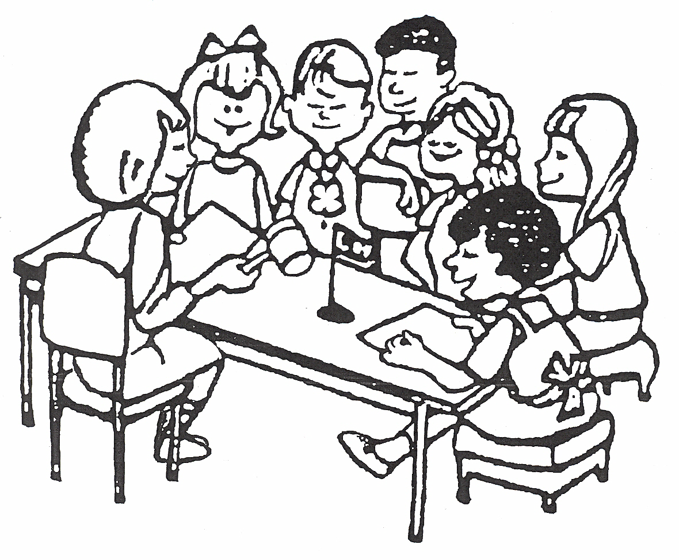
- Orderly way to conduct a meeting.
- Fair way to make a group decision.
- Respects everyone.
PARLIAMENTARY PROCEDURE FOR 4-H CLUBS
- Gives everyone a chance to speak.
- Majority rules, minority protected.
- Used in groups everywhere.

MEETING: Run by President or presiding Officer.

Be “Recognized” by the President before speaking.
Stand up to speak.
Only one speaker at a time.
Speak only on the subject under discussion.
Make decisions by Motion (I move…..).
Motion requires a second.
Discuss motion until everyone has had a chance to speak.
Vote…..Voice Vote or Show of Hands or Secret Ballot.
TO MAKE A MOTION:

“I move….. “[I move our club visit the Nursing Home on the day before Thanksgiving.
I move we donate $50.00 to Special Olympics, etc. I move….] Proper way to second a motion…. “I second the motion”. No thirds, fourths or fifths required or desired.

This type of motion is called the main motion. It is the one you will use most of the time in your 4-H club. There can be only one main motion at a time.

MOTION TO AMEND:

To amend means to change. The motion to amend is made if you want to change the main motion. You can change the motion by adding something to it, changing some words or taking something out of the motion. “I move to amend the motion by [adding] [changing] [deleting] what you want changed. The motion to amend requires a second. Discuss the amendment only. Vote on the amendment only.

If the amendment passes then the main motion is changed – if it does not, then the main motion is not changed. Then discuss the main motion (as amended if the amendment passed). Vote on the main motion.

MOTION TO ADJOURN: “I move to adjourn this meeting”.

- Do not have discussion.
- Must be voted on right away.

- Made to end the meeting.
- Needs a “second”.

There are over 30 different types of motions. These are the basic ones you need to know for a
4-H Club. Call the 4-H office if you want to learn more about Parliamentary Procedure.

