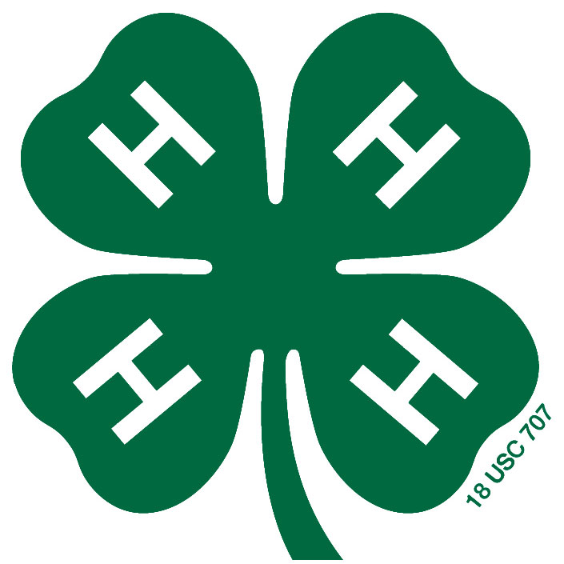
Central Kansas District
Date Received:

Date Approved:

4-H Council Scholarship Application

Date: Name:
Club: Email Address:
Home Phone: ( ) - Cell Phone: ( ) -
Note: One Scholarship Application is Required for each Event
Event Scholarship Requested For:

4-H Camp
4-H Campference
Citizenship Washington Focus (CWF)
Discovery Days
National 4-H Congress
Kansas Youth Leadership Forum (KYLF)
Citizenship In Action (CIA)
Specialty Camps (i.e., photo camp, sewing camp, horse panorama, etc.)
Specify:

Date of Event:

If application is not complete, then the applicant will be
required to pay the full registration fee by the registration deadline.

Application is due 5 p.m. by the registration deadline. Any applications received after 5 p.m. on the registration deadline will not be considered for a scholarship.

4-H Camp requires item 1 below and a paragraph on “Why I want to attend 4-H Camp.”

4-H Campference, Citizenship In Action (CIA), Discovery Days, Kansas Youth Leadership Forum (KYLF) and Specialty Camps all require items 1 and 2 below PLUS 2 additional items from the list. A presentation to 4-H Council and/or my 4-H club promoting the 4-H event I attended and what I learned is also required.

Citizenship Washington Focus (CWF), National 4-H Congress, and National 4-H Conference require items 1 and 2 below PLUS 5 additional items from the list. A presentation to 4-H Council and/or my 4-H club promoting the 4-H event I attended and what I learned is also required.

1. Attended a majority (50% +1) of your regularly scheduled 4-H Club Meetings within the last 12 months of the date on the application or by the date at which you joined 4-H.

2. Participation in one (1) Districtwide 4-H Council Fundraiser within the last 12 months of the date on the application. (check all that apply)
Red Wheel Sales (sold at least 3 items)
Pop Stand at the Tri-Rivers Fair (worked at least 1 hour)
Other:
(if items are sold, needs to have sold at least 3 items or worked at least 1 hour)

3. Participated in the most recent District 4-H Club Day (in a presentation or as a room monitor) and/or Gavel Game/Model Meeting Contest.

4. Presented a demonstration, illustrated talk or project talk at a club meeting with in the last 12 months of the date on the application.
5. Exhibited at the most recent county fair.

6. Actively participate on a 4-H Club or 4-H Council committee. Circle one: Club Council
Name of Committee:

7. Attended the 4-H Celebration of Achievements, Officer Training and Family Event or other Districtwide event this past 4-H year. Name of Event:

8. Currently serving in a leadership role for your club or district (i.e., club officer, committee chair, project leader). Leadership Role:

9. Participated in a community service event with your club or Districtwide Youth Service Day. Community Service Event:

10. KAP was submitted for the District Contest the previous 4-H year.

11. Received a KAP Award, Achievement Pin or Key Award in the previous 4-H year.
Award Received:

12. Take part in a 4-H District, Regional or State Judging Contest.
Contest: Date:

After the Applicant has Returned from the 4-H Event:

When applicant has returned from the 4-H event indicated on this application and has made a presentation to his/her 4-H club, he/she must receive the organizational leader signature (on a supplemental form) and submit to either Extension Office within three months of attending the event indicated in this scholarship application. If a presentation is made at District 4-H Council, that will be recorded in the minutes and the Extension Staff will make sure that the credit is given to the applicant. The scholarship process is not complete until this has been done. Just as a reminder, if no presentation is made within 3 months of attending the 4-H event, then the 4-H member will not be eligible for an event scholarship for the next event he/she attends. Following said event, the 4-H member may apply for another 4-H Council Scholarship.

Note: No presentation is required for 4-H camp, but is strongly encouraged!

Signature of the Organizational Leader signifies that the club information on this application is accurate to the best of their knowledge.

Signature of Organizational Leader Date

I understand that I will be required to give a presentation to 4-H Council and/or my 4-H Club promoting the 4-H event I attended and what I learned. The presentation must be made within 3 months of the 4-H event. If no presentation is made, then it will affect me receiving a scholarship from 4-H Council in the future. No presentation is required for 4-H camp, but is strongly encouraged!

4-H Member Signature Date

